Go to SE24. Create class as below. **Please mention your empcode instead of 104329**.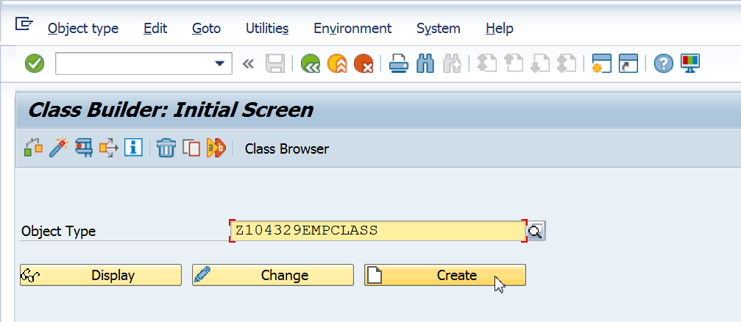

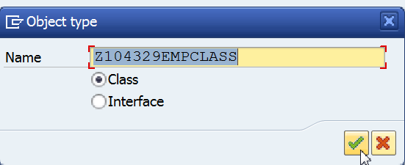

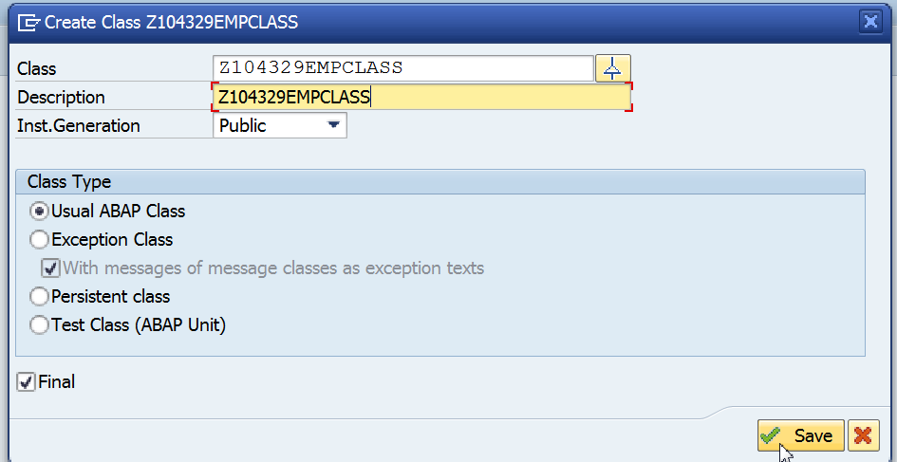

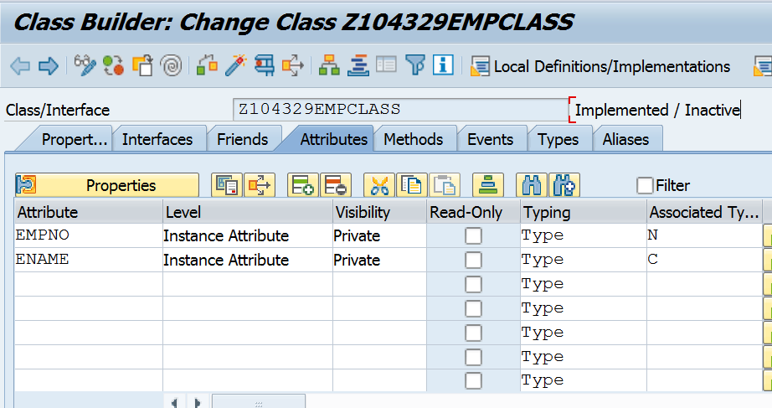

Click on

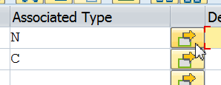

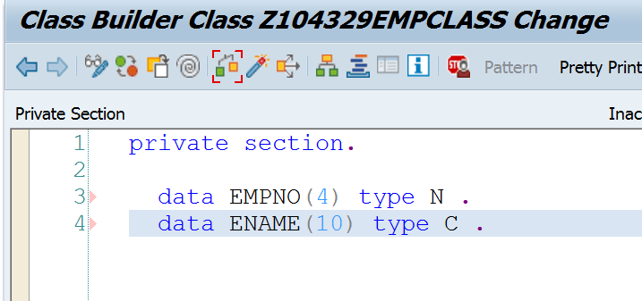

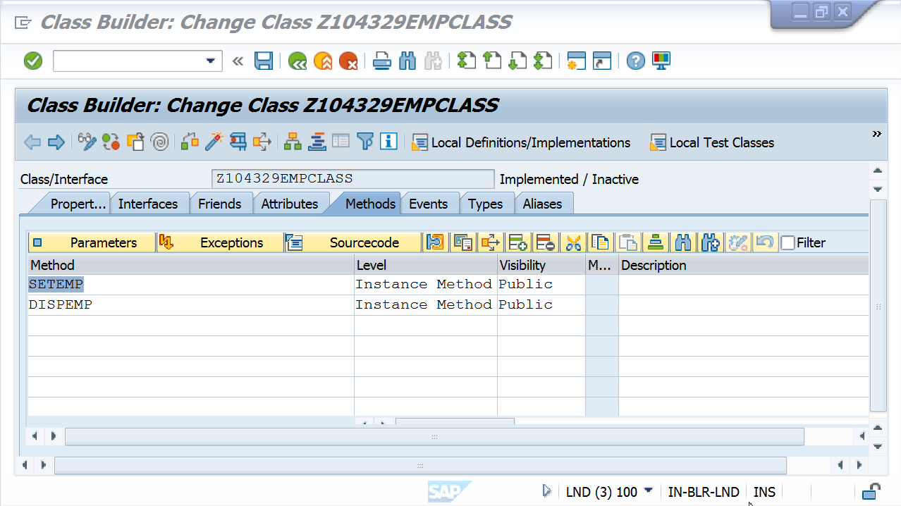

Click on Parameters as shown in screen below. 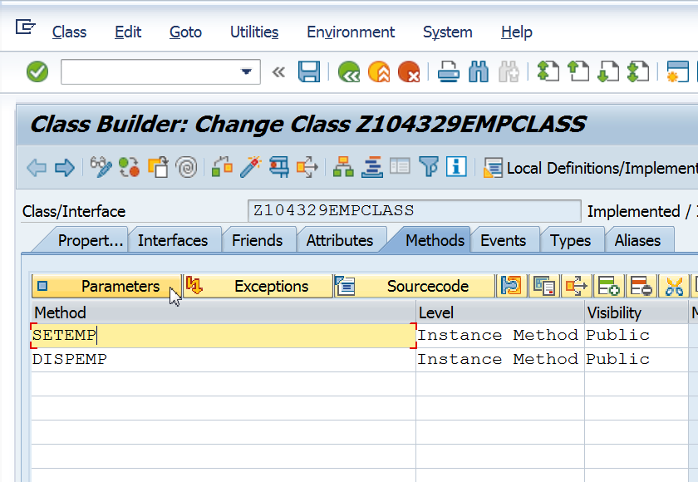

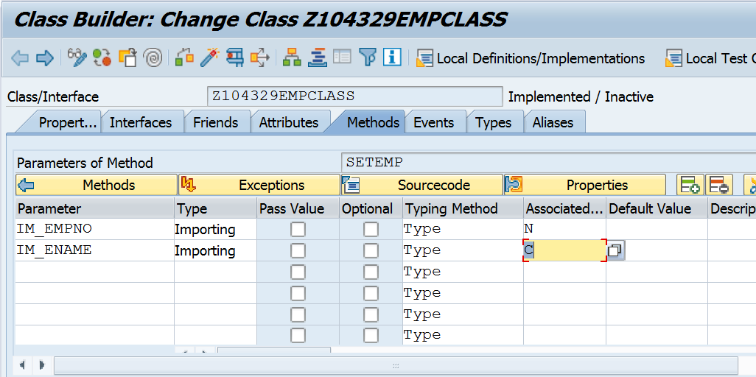

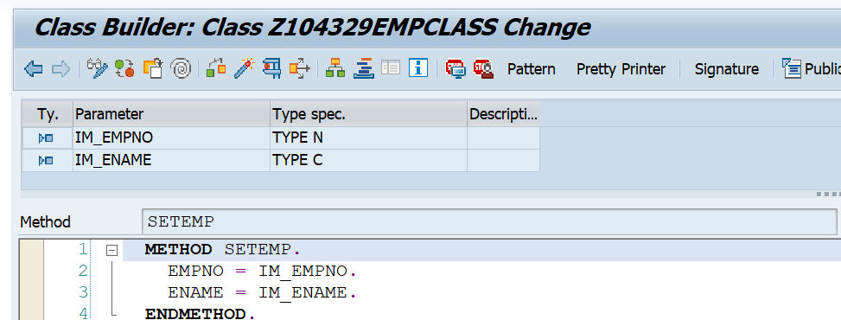

  method SETEMP.  
    EMPNO = IM_EMPNO.  
    ENAME = IM_ENAME.  
  endmethod.

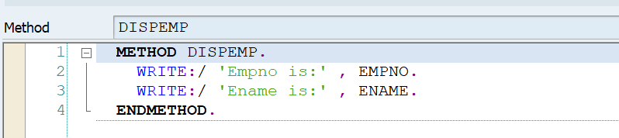

  method DISPEMP.  
  
    WRITE: 'Empno is :', Empno.  
    WRITE: 'Ename is :', Ename.  
  endmethod.

Code SE38 pgm as below

REPORT Z.  
  
DATA EMP1 TYPE REF TO Z104329EMPCLASS.  
CREATE OBJECT EMP1.  
  
CALL METHOD EMP1->SETEMP  
    EXPORTING  
      IM_EMPNO = 99  
      IM_ENAME = 'Ram'.  
EMP1->DISPEMP( ).